.Net

Introduction
.Net Framework is based on Windows based operating system.
- Net Framework includes 2 main components:
  - Common Language Runtime (CLR)
Responsible for managing the execution of code written in any of the supported languages
  - .Net Framework Class Library
It provides a large set of pre-build functions and classes that can be used to create a wide range of applications
- Variety of programming languages
- Variety of application types like desktop, web, mobile and gaming
- Provides several features that help improve the security, reliability and performance of applications
- Designed to integrate with other Microsoft technologies such as Microsoft SQL server, Microsoft SharePoint and Microsoft Office.
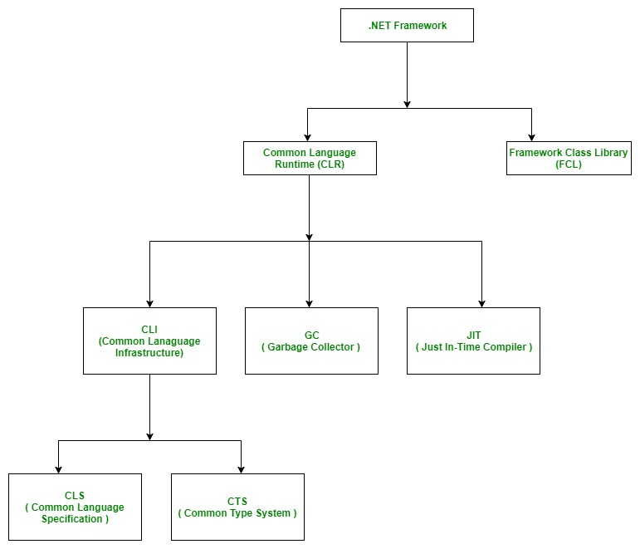

Basic Architecture and Component Stack

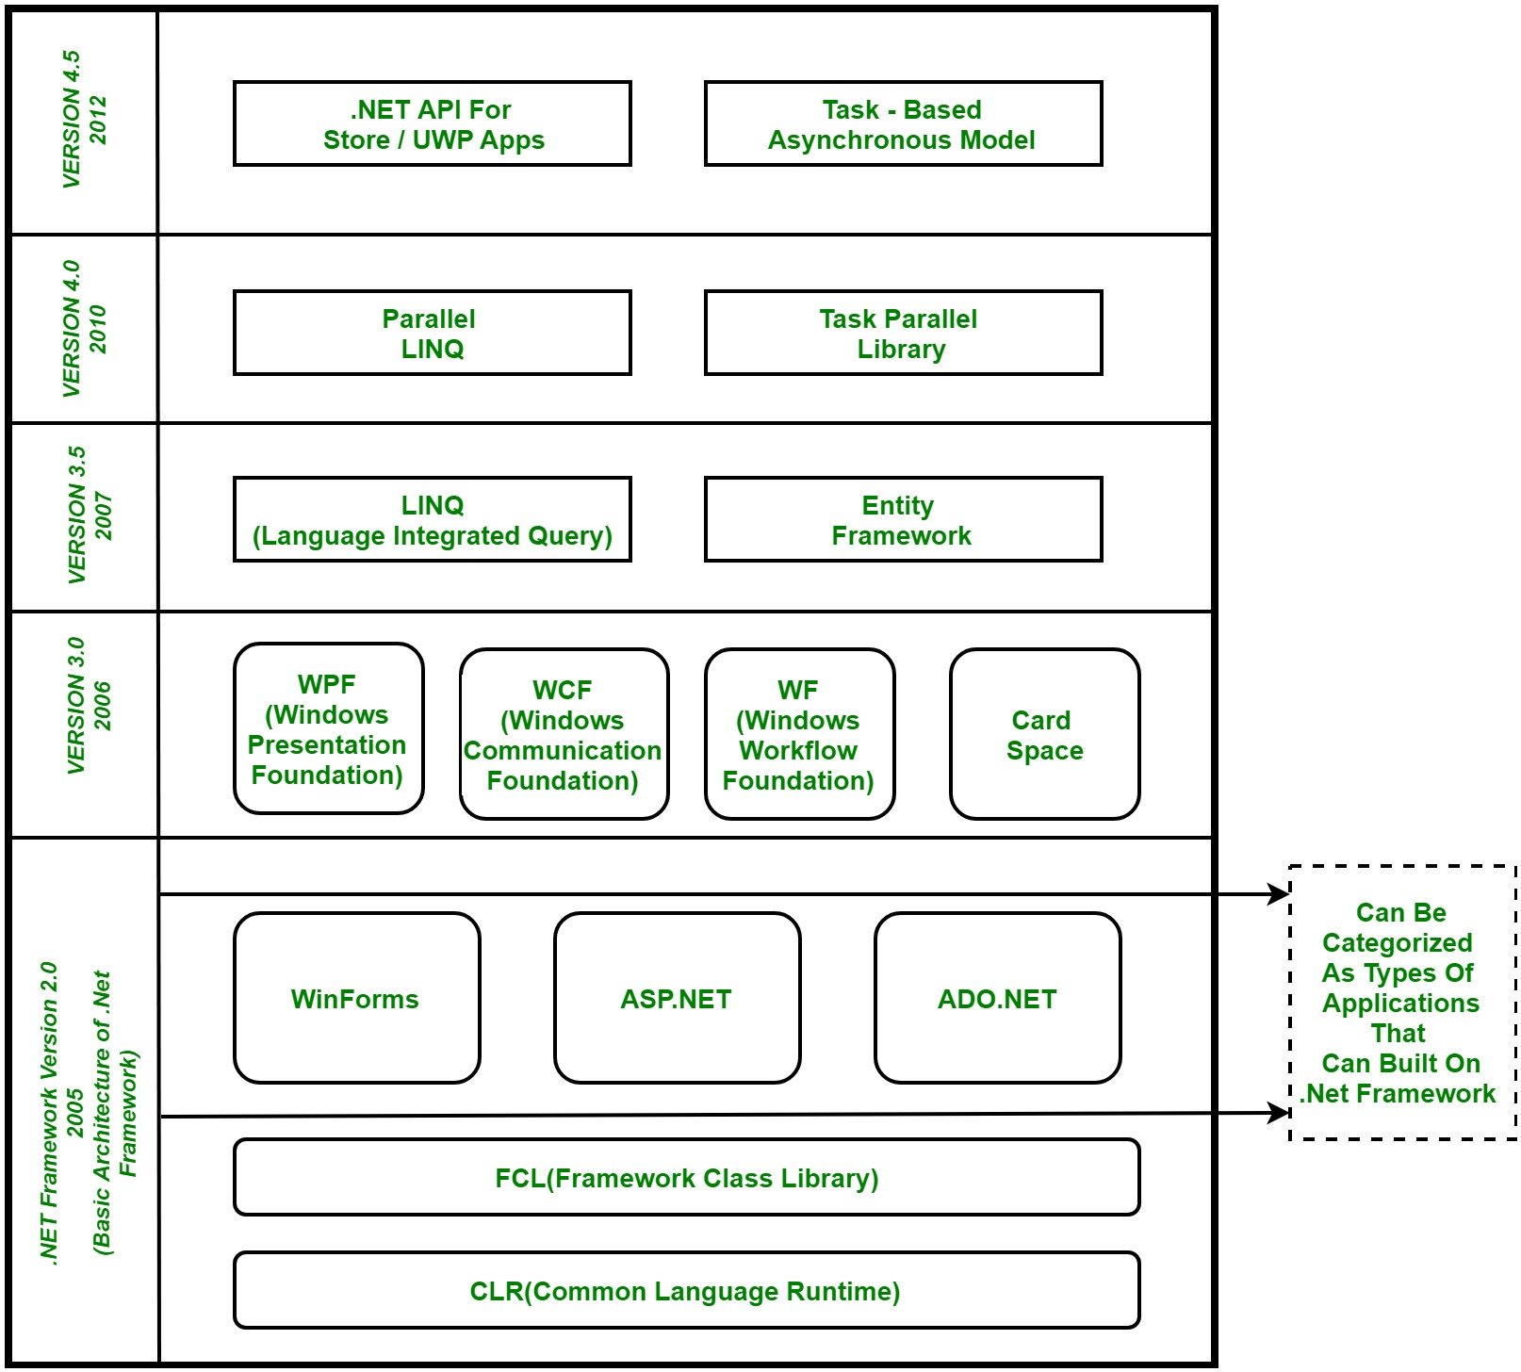

Identifiers
These are used for identification purposes such as class, method or variable name.
Rules should be followed to create an identifier:
- It allows alphanumeric characters like A-Z, a-z, 0-9, _(underscore).
- It should not start with numbers.
- It should not contain white spaces
- Keywords are not used as identifiers unless it prefixes with @ Ex: @as is valid identifier, because as is keyword
- It allows Unicode characters.
- It is a Case-Sensitive.
- Should not be more than 512 characters.
- Cannot contain 2 consecutive underscores because they are used for implementation.

Variables
Characters of Variables:
- It must be a valid identifier.
- Type of identifier
- Value
Variable name rules:
- It allows alphanumeric characters like A-Z, a-z, 0-9, _(underscore).
- It should not start with numbers.
- It cannot be a C# keywords.
int y = 7; // Declaring and initializing the variable at same time
int x; // Declaring variable x
x = 5; // initializing x with value 5

Data Types
C# is a strongly typed Programming Language. C# has 3 different types of Data Types.
- Value Types
It stores value in the memory directly and stores both signed and unsigned values.
- Reference Types
- Pointer Types.

Operators
Operators are the foundation of any programming language. Thus, the functionality of C# language is incomplete without the use of operators. Operators allow us to perform different kinds of operations on operands. In C#, operators Can be categorized based upon their different functionality:

Arithmetic Operators
Relational Operators
Logical Operators
Bitwise Operators
Assignment Operators
Conditional Operator

Keywords

abstract | class | event | if | new | readonly | struct | unsafe
as | const | explicit | implicit | null | ref | switch | ushort
base | continue | extern | in | object | return | this | using
bool | decimal | FALSE | int | operator | sbyte | throw | using static
break | default | finally | interface | out | sealed | TRUE | virtual
byte | delegate | fixed | internal | override | short | try | void
case | do | float | is | params | sizeof | typeof | volatile
catch | double | for | lock | private | stackalloc | unit | while
char | else | foreach | long | protected | static | ulong
checked | enum | goto | namespace | public | string | unchecked

Decision Making
If, If else, if else if, Nested if, Switch, Nested Switch

If(condition){statement}
If (condition){statement} else {statement}
If(condition){statement} else if (condition){statement} else{statement}
Switch(variable) {
Case value: statement; break;
Case value2: statement; break;
Default: statement; break;
}

Loops
Entry Controlled Loops (While, for)
Exit Controlled Loops (do-while)

While(condition){statement;}
For (variable initialization; testing condition; increment/ decrement ){statement;}
Do (statement;) while(condition){statement;}

Jump Statements
Break, continue, goto, return, throw

Break: exits the loop
Continue: use to skip the continues statements and move to next iteration of the loop
Goto: moves the execution of code to labeled statement
Goto label;
Statement;
Label: statement;
Return: exits the method and returns to the calling method.
Throw: This is used to create an object of any valid exception class with the help of new keyword manually

Class and Object
A Class is a reference type, which will have null value when you declare it until you explicitly create an instance of the class by using new operator.

When an object is created, enough memory is created in Managed heap for that specific object, and the carriable holds only a reference to the location of said object. The memory used by an object is reclaimed by the automatic memory management functionality of the CLR, which is known as garbage collection.

Declaring the class by using class keyword, default access modifier for a class is internal
[Access modifier] [class] [identifier]
Public class class_name{}

Objects and Classes are different things. A class defines a type of object, but it isn’t an object itself. An object is a concrete entity based on a class and is sometimes referred to as an instance of a class. Objects can be created by using the new keyword followed by the name of the class.

When an instance of a class is created, a reference to the object is passed back to the programmer.

Constructors and initialization:
Types of initialize values:
Accept default values
Field initializers
Constructor parameters
Object initializers
Default values for int variables are zero and reference variables is null
Field Initializer
public class Container
{
// Initialize capacity field to a default value of 10:
private int _capacity = 10;
}
Constructor Parameter
public class Container
{
private int _capacity;

public Container(int capacity) => _capacity = capacity;
}
Object Initializer
public class Person
{
public required string LastName { get; set; }
public required string FirstName { get; set; }
}
var p1 = new Person(); // Error! Required properties not set
var p2 = new Person() { FirstName = "Grace", LastName = "Hopper" };

Constructor
- Default Constructor
- Parameterized Constructor
- Copy Constructor
- Private Constructor
- Static Constructor

Default Constructor: Constructor without parameter
Parameterized Constructor: Constrictoe having parameters
Copy Constructor: Creates an object by copying variables from another object
Class1 c1 = new class1(parameters);
Class1 c2 = new class1(c1);
Private Constructor: The constructor created with private modifier. We cannot create instance or derive class.
- It is used in singleton class pattern
- We use this method when we have static members only
- It prevents creating the instances
public class Geeks {

// declare private Constructor
private Geeks ()
{
}

// declare static variable field
public static int count_geeks;

// declare static method
public static int geeks_Count ()
{
return ++count_geeks;
}
}

Static Constructor: Static Constructor must be invoked only once in the class, and it has been invoked during the creation of the first reference to a static member in the class. A static constructor is initialized static fields or data of the class and to be executed only once.
- It cannot be called directly
- When it is executing then the use has no control
- It does not take access modifiers or any parameters
- It is called automatically to initialize the class before the first instance created.
- A class or struct can only have one static constructor
class geeks {
// It is invoked before the first
// instance constructor is run.
static geeks ()
{

// The following statement produces
// the first line of output,
// and the line occurs only once.
Console.WriteLine("Static Constructor");
}

// Instance constructor.
public geeks (int i)
{
Console.WriteLine("Instance Constructor " + i);
}

// Instance method.
public string geeks_detail (string name, int id)
{
return "Name:" + name + " id:" + id;
}

// Main Method
public static void Main ()
{

// Here Both Static and instance
// constructors are invoked for
// first instance
geeks obj = new geeks (1);
Console.WriteLine(obj.geeks_detail("GFG", 1));

// Here only instance constructor
// will be invoked
geeks obj1 = new geeks (2);
Console.WriteLine(obj1.geeks_detail ("GeeksforGeeks", 2));
}
}

Inheritance
C# supports 4 different inheritances.
- Single inheritance: A derived class that inherits from only one base class.
- Multi-level inheritance: A derived class that inherits from a base class which is derived class from another base class.
- Hierarchical inheritance: A base class that serves as a parent class for two or more derived classes
- Multiple inheritance: A derived class that inherits from two or more base classes
using System;

// single inheritance
class Animal {
public void Eat() {
Console.WriteLine("Animal is eating.");
}
}

class Dog : Animal {
public void Bark() {
Console.WriteLine("Dog is barking.");
}
}

// multi-level inheritance
class Mammal : Animal {
public void Run() {
Console.WriteLine("Mammal is running.");
}
}

class Horse : Mammal {
public void Gallop() {
Console.WriteLine("Horse is galloping.");
}
}

// hierarchical inheritance
class Bird : Animal {
public void Fly() {
Console.WriteLine("Bird is flying.");
}
}

class Eagle : Bird {
public void Hunt() {
Console.WriteLine("Eagle is hunting.");
}
}

class Penguin : Bird {
public void Swim() {
Console.WriteLine("Penguin is swimming.");
}
}

// multiple inheritance
interface I1 {
void Method1();
}

interface I2 {
void Method2();
}

class MyClass : I1, I2 {
public void Method1() {
Console.WriteLine("Method1 is called.");
}

public void Method2() {
Console.WriteLine("Method2 is called.");
}
}

// main program
class Program {
static void Main(string[] args) {
// single inheritance
Dog dog = new Dog();
dog.Eat();
dog.Bark();

// multi-level inheritance
Horse horse = new Horse();
horse.Eat();
horse.Run();
horse.Gallop();

// hierarchical inheritance
Eagle eagle = new Eagle();
Penguin penguin = new Penguin();
eagle.Fly();
eagle.Hunt();
penguin.Fly();
penguin.Swim();

// multiple inheritance
MyClass myClass = new MyClass();
myClass.Method1();
myClass.Method2();

Console.ReadLine();
}
}

Output:
Animal is eating.
Dog is barking.
Animal is eating.
Mammal is running.
Horse is galloping.
Bird is flying.
Eagle is hunting.
Bird is flying.
Penguin is swimming.
Method1 is called.
Method2 is called.

Advantages
- Code Reusability: Inheritance allows us to reuse existing code by inheriting properties and methos from an existing class.
- Code Maintenance: Inheritance makes code maintenance easier by allowing us to modify the base class and have the changes automatically reflected in the derived classes.
- Code Organization: Inheritance improves code organization by grouping related classes together in a hierarchical structure.
Disadvantage:
- Tightly Coupling: Inheritance creates a tight coupling between the base class and the derived class, which can make the code more difficult to maintain.
- Complexity: Inheritance can increase the complexity of the code by introducing additional levels of abstraction.
- Fragility: Inheritance can make the code more fragile by creating dependencies between the base class and derived class.

Collections
Collections standardize the way of which the objects are handled by your program. In other words, it contains a set of classes to contain elements in a generalized manner. With the help of collections, the user can perform several operations on objects like the store, update, delete, retrieve, search, sort etc.
C# divide collection in several classes, some of the common classes are shown below:
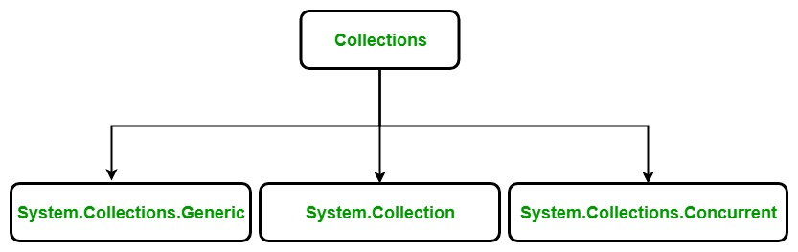
System.Collections.Generic Classes
Generic collection in C# is defined in System.Collection.Generic namespace. It provides a generic implementation of standard data structure like linked lists, stacks, queues, and dictionaries. These collections are type-safe because they are generic means only those items that are type-compatible with the type of the collection can be stored in a generic collection, it eliminates accidental type mismatches. Generic collections are defined by the set of interfaces and classes. Below table contains the frequently used classes of the System.Collections.Generic namespace:
Class name | Description
Dictionary<TKey,TValue> | It stores key/value pairs and provides functionality similar to that found in the non-generic Hashtable class.
List<T> | It is a dynamic array that provides functionality similar to that found in the non-generic ArrayList class.
Queue<T> | A first-in, first-out list and provides functionality similar to that found in the non-generic Queue class.
SortedList<TKey,TValue> | It is a sorted list of key/value pairs and provides functionality similar to that found in the non-generic SortedList class.
Stack<T> | It is a first-in, last-out list and provides functionality similar to that found in the non-generic Stack class.
HashSet<T> | It is an unordered collection of the unique elements. It prevent duplicates from being inserted in the collection.
LinkedList<T> | It allows fast inserting and removing of elements. It implements a classic linked list.
Example:
// C# program to illustrate the concept
// of generic collection using List<T>
using System;
using System.Collections.Generic;

class Geeks {

// Main Method
public static void Main(String[] args)
{

// Creating a List of integers
List<int> mylist = new List<int>();

// adding items in mylist
for (int j = 5; j < 10; j++) {
mylist.Add(j * 3);
}

// Displaying items of mylist
// by using foreach loop
foreach(int items in mylist)
{
Console.WriteLine(items);
}
}
}
Output:
15
18
21
24
27

List:
Constructor:
List<T>()
List<T>(Enumerator<T>)
List<T>(Int32)

System.Collections Classes
Non-Generic collection in C# is defined in System.Collections namespace. It is a general-purpose data structure that works on object references, so it can handle any type of object, but not in a safe-type manner. Non-generic collections are defined by the set of interfaces and classes. Below table contains the frequently used classes of the System.Collections namespace:
Class name | Description
ArrayList | It is a dynamic array means the size of the array is not fixed, it can increase and decrease at runtime.
Hashtable | It represents a collection of key-and-value pairs that are organized based on the hash code of the key.
Queue | It represents a first-in, first out collection of objects. It is used when you need a first-in, first-out access of items.
Stack | It is a linear data structure. It follows LIFO(Last In, First Out) pattern for Input/output.
Example:
// C# to illustrate the concept
// of non-generic collection using Queue
using System;
using System.Collections;

class GFG {

// Driver code
public static void Main()
{

// Creating a Queue
Queue myQueue = new Queue();

// Inserting the elements into the Queue
myQueue.Enqueue("C#");
myQueue.Enqueue("PHP");
myQueue.Enqueue("Perl");
myQueue.Enqueue("Java");
myQueue.Enqueue("C");

// Displaying the count of elements
// contained in the Queue
Console.Write("Total number of elements present in the Queue are: ");

Console.WriteLine(myQueue.Count);

// Displaying the beginning element of Queue
Console.WriteLine("Beginning Item is: " + myQueue.Peek());
}
}
Output:
Total number of elements present in the Queue are: 5
Beginning Item is: C#
Note: C# also provides some specialized collection that is optimized to work on a specific type of data type and the specialized collection are found in System.Collections.Specialized namespace.

System.Collections.Concurrent
It came in .NET Framework Version 4 and onwards. It provides various threads-safe collection classes that are used in the place of the corresponding types in the System.Collections and System.Collections.Generic namespaces, when multiple threads are accessing the collection simultaneously. The classes present in this collection are:
Class name | Description
BlockingCollection | It provides blocking and bounding capabilities for thread-safe collections that implement  IProducerConsumerCollection.
ConcurrentBag | It represents a thread-safe, an unordered collection of objects.
ConcurrentDictionary | It represents a thread-safe collection of key/value pairs that can be accessed by multiple threads concurrently.
ConcurrentQueue | It represents a thread-safe first in-first out (FIFO) collection.
ConcurrentStack | It represents a thread-safe last in-first out (LIFO) collection.
OrderablePartitioner | It represents a particular manner of splitting an orderable data source into multiple partitions.
Partitioner | It provides common partitioning strategies for arrays, lists, and enumerables.
Partitioner | It represents a particular manner of splitting a data source into multiple partitions.
List:
Method | Description
Add() | Add the item to the end of the List. The value can be null for reference types.
AddRange() | The collection whose elements should be added to the end of the List<T>. The collection itself cannot be null, but it can contain elements that are null, if type T is a reference type.
AsReadOnly() | An object that acts as a read-only wrapper around the current List<T>.
BinarySearch()  BinarySearch(T)  BinarySearch(T Item, System.Collections.Generic.IComparer<T>? comparer  BinarySearch(int index, int count, T item, System.Collections.Generic.IComparer<T>? comparer) | Searches the entire sorted List<T> for an element using the default comparer and returns the zero-based index of the element.  Searches the entire sorted List<T> for an element using the specified comparer and returns the zero-based index of the element.  Searches a range of elements in the sorted List<T> for an element using the specified comparer and returns the zero-based index of the element.
Clear() | Removes all elements from the List<T>
Contains() | Determines whether an element is in the List<T>
ConvertAll() | Converts the elements in the current List<T> to another type, and returns a list containing the converted elements.

Design Patterns
Creational | Structural | Behavioral
Abstract | Adapter | Chain of Responsibility
Builder | Bridge | Command
Factory Method | Composite | Iterator
Prototype | Decorator | Mediator
Singleton | Façade | Memento
 | Flyweight | Observer
 | Proxy | State
 |  | Strategy
 |  | Template Method
 |  | Visitor

- Creational patterns provide object creation mechanisms that increase flexibility and reuse of existing code.
- Structural patterns explain how to assemble objects and classes into larger structures, while keeping these structures flexible and efficient.
- Behavioral patterns take care of effective communication and the assignment of responsibilities between objects.

